Lab 5-1 Importing Additional Product Tables
Goals | To import normalized tables that contain additional product information into the Physical layer of the repository.
Scenario | There are product tables that store detail information about ABC’s products. You want to add these tables to the Product dimension in the Business Model and Mapping layer. You will import these tables into the repository and create keys and foreign key joins for the tables.
Outcome | In the Physical layer, d1_pricelist, D1_prod_diet_types, D1_product_subtype, D1_product_type, and d1_suppliers tables and associated keys and joins.
Time | 5 – 10 minutes
Environment | 
Instructions
- Verify that the Siebel Analytics Server is stopped.
  - Select Start > Programs > Administrative Tools > Services.
  - Locate Siebel Analytics Server and verify that the status field has no value.
  - Minimize Services.
- Start the Siebel Analytics Administration Tool and open the ABC.rpd repository offline.
  - Select Start > Programs > Siebel Analytics > Siebel Analytics Administration.
  - Select File > Open > Offline.
  - Double-click ABC.rpd.
  - Verify that User is Administrator and Password field is blank.
  - Click OK.
- Import the product tables that store product code, pricing, and supplier (vendor) information.
  - Select File > Import > from Database.
  - Verify that the connection type is ODBC 3.5.
  - Scroll down and select the ABC data source.
  - In the User Name field, verify that sa is the value and leave the Password field blank.
  - Click OK.
  - Expand the supplier2 folder.
  - Expand the dbo folder.
  - Select the following tables (use CTRL+click) to import:
Table Name
d1_pricelist
D1_prod_diet_types
D1_product_subtype
D1_product_type
d1_suppliers
  - Verify that the Tables, Keys, and Foreign Keys check boxes are selected.
  - Click Import.
  - Click Close.
- Define joins and foreign keys using the Physical Diagram view.
Note: The tables you imported provide more detail information about ABC’s products, such as product type (example: Cheese or Beef), subtype (example: American cheese or Beef patties), and diet codes (example: Diet or Regular). These tables represent a one-to-many relationship to the D1_products table.
  - In the Physical layer, right-click the ABC database and select Physical Diagram > Object(s) and All Joins to open the Physical Diagram view.
  - Drag the new table objects so they are all visible.
  - Use the New Foreign Key button on the Tool bar to create the following relationships:
Note: Reply Yes to the message asking if you want to create a matching table key.
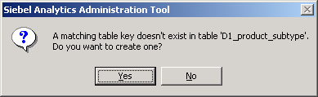
Dimension key | Foreign key
D1_product_subtype.SubtypeCode | D1_products.SubtypeCode
D1_prod_diet_types.DietCode | D1_products.DietCode
d1_suppliers.SupplierCode | D1_products.SupplierCode
d1_pricelist.ProductKey | D1_products.ProductKey
D1_product_type.TypeCode | D1_product_subtype.TypeCode
  - Check your results:
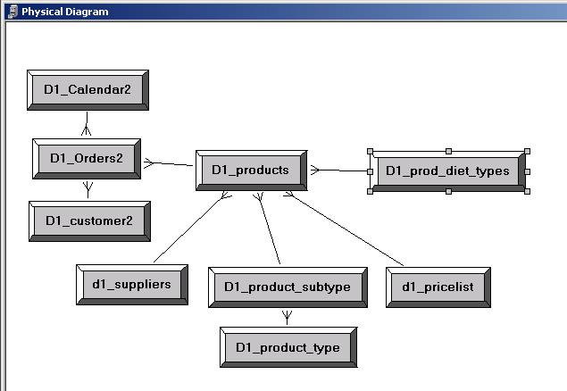
  - Close the Physical Diagram.

Lab 5-2 Creating Multiple Sources for a Logical Table Source (Manual)
Goals | To add the information from the price list table to the Product dimension.
Scenario | You have imported the product tables that store detail information about ABC’s products into the Physical layer of the repository and configured keys and foreign key joins for the tables. Thus far, the Product dimension in the Business Model and Mapping layer includes only information from the root product table: D1_products. You are ready to add the information from the price list table to the Product dimension, and while doing that, simplify the data structure (in effect, creating a denormalized logical table).
Outcome | In the Business Model and Mapping layer, the d1_pricelist physical table is added to the existing logical table source for the Product dimension.  In the Business Model and Mapping layer, the Price logical column is added to the Product dimension and mapped to the appropriate physical table.
Time | 5 minutes
Instructions:
- Add the information from the price list table to the existing logical table source for the Product dimension.
Note: There are two methods to model multiple sources for an existing logical table source. In this lab you will use the Properties window of an existing logical table source, which is a manual process and requires several steps. In a subsequent lab, you will use a more automated process.
  - In the Business Model and Mapping layer, expand the Sources folder of the Products table and double-click the D1_products logical table source to view the properties.
  - Click the General tab and click Add.
  - In the Browse window, select the d1_pricelist table and click the Select button.
  - Click OK.
- Now that the physical table that stores the pricing information has been added to the Product logical table source, create a new logical column and map it to the appropriate physical table.
  - In the Business Model and Mapping layer, right-click the Products table and select New Object > Logical Column.
  - Enter Price in the Name field and click OK.
  - Open the Properties window of the D1_products logical table source.
  - Click the Column Mapping tab.
  - Select the Show unmapped columns check box.
  - In the Logical Column section, click the Price ellipsis (…) button to open the Expression Builder.
  - In the lower-left pane of the Expression Builder, click the Physical Tables folder.
  - In the center pane, click d1_pricelist.
  - In the right pane, click Price.
  - Select Insert and examine the expression.
  - Click OK to close the Expression Builder.
  - Verify that Show Mapped Columns is selected, and that d1_pricelist appears in the Physical Table column.
  - Click OK.
Lab 5-3 Creating Multiple Sources for a Logical Table Source (Automated)
Goals | To add the information from the additional product tables to the Product dimension.
Scenario | So far, you have added the information from the price list table to the Product dimension. You are ready to add information from the other product tables to the Product dimension using an alternative method. You will create multiple sources for the Product logical table source that simultaneously adds the columns to the Product dimension.
Outcome | In the Business Model and Mapping layer, the D1_prod_diet_types, D1_product_subtype D1_product_type, and d1_suppliers physical tables are added to the existing logical table source for the Products logical table.  In the Business Model and Mapping layer, the Diet_type, ItemSubtype, ItemType, and ItemSupplier logical columns are added to the Products logical table and mapped to the appropriate physical tables.
Time | 5 – 10 minutes
Instructions:
- Add additional information to the Product dimension and simultaneously add a new source to the existing D1_products logical table source.
  - In the Physical layer, expand the D1_prod_diet_types table and locate the Diet_type column.
  - In the Physical layer, drag the Diet_type column onto the D1_products logical table source in the Products dimension in the Business Model and Mapping layer.
  - Verify your results.
    - Was the Diet_type column added to the Product dimension?
    - View the properties of the D1_products logical table source.
    - Click the Column Mapping tab. Is the Diet_type column mapped to the D1_prod_diet_types physical table?
    - Click Cancel.
- Repeat the above steps to add the following product information to the Products dimension, simultaneously adding new sources to the existing D1_products logical table source:
Physical Table | Physical Column
D1_product_subtype | ItemSubtype
D1_product_type | ItemType
d1_suppliers | ItemSupplier
  - Verify your results.
    - Open the D1_products logical source Properties window and click the Column Mapping tab to verify your results.
    - What new table sources were added to the D1_products logical table source? It may be necessary to scroll to the right.
  - Click OK.
- Rename the new logical columns in the Product dimension so they are meaningful to users.
  - In the Business Model and Mapping layer, double-click the Diet_type logical column to open the Properties window.
  - To rename the column, enter Diet Type in the name field.
  - Click OK.
  - Rename the other new columns to the following:
From… | To…
ItemSubtype | Subtype
ItemType | Type
ItemSupplier | Supplier
- Add the new product information to the SupplierSales presentation catalog.
  - Drag the five new columns onto the Products table in the SupplierSales presentation catalog and reorder the columns as follows:
Column Name
Price
Type
Subtype
Diet Type
Supplier
- Select File > Check Global Consistency to validate your work.
- Select File > Save to save your work.
- Select File > Exit to close the Administration Tool.
- Restart the Siebel Analytics Server and Siebel Analytics Web services.
  - Select Start > Programs > Administrative Tools > Services.
  - Restart the Siebel Analytics Server and Siebel Analytics Web services.
  - Minimize the Services window.
- Start Siebel Answers.
  - Select Start > Programs > Siebel Analytics > Siebel Analytics Web.
  - Enter the following parameters:
User | Administrator
Password | <blank>
  - Click Log In.
  - Click the Answers link.
- Create a request.
  - Select the SupplierSales subject area.
  - Create the following request:
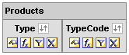
  - Click the Results tab to view the results.
- Examine the query log to determine which table or tables have been accessed for this simple query.
  - Double-click C:\SiebelAnalytics\Log\NQQuery.log.
  - Scroll down and verify that three tables: D1_products, D1_product_subtype, and D1_product type, have all been accessed, despite the fact that the D1_product_type table alone contains all the data requested.
  - Select File > Exit to close the query log.
Note: In the next lab, you will specify a more economical way for the Analytics Server to access this data.
- Select File > Close to close Siebel Answers.
Solutions 5-3 Creating Multiple Sources for a Logical Table Source (Automated)
Answers
1.c.i. Was the Diet_type column added to the Product dimension?
Yes
1.c.iii. Click the Column Mapping tab. Is the Diet_type column mapped to the D1_prod_diet_types physical table?
Yes
2.a.ii. What new table sources were added to the D1_products logical table source? D1_prod_diet_types, D1_product_subtype, D1_product_type, and d1_suppliers
10.c. Click the Results tab to view the results.
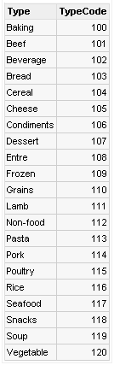
11.b. Scroll down and verify that three tables: D1_products, D1_product_subtype, and D1_product type, have all been accessed, despite the fact that the D1_product_type table alone contains all the data requested.
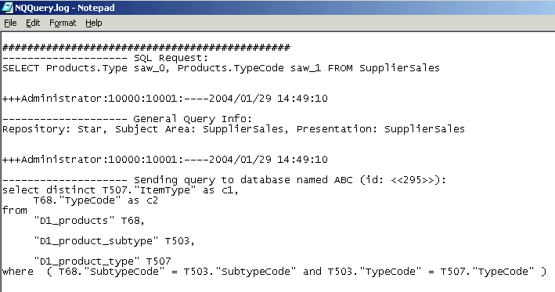

Lab 5-4 Specifying the Most Economical Source
Goals | Add a second logical table source to the Product dimension.
Scenario | In examining the physical sources and the Products dimension table, you discover that the columns, TypeCode and Type, are mapped to different physical tables, while the information for both is stored in a common physical table.  In order to model the most economical method for the Siebel Analytics Server to find information for these two columns, you decide to add a second logical table source to the Product dimension so that the Siebel Analytics Server queries only one table for the TypeCode and Type information.
Outcome | In the Business Model and Mapping layer, Type is added as second logical table source for the Products logical table.
Time | 5 minutes
Instructions:
- Open the Siebel Analytics repository file.
  - Shut down the Siebel Analytics Server service.
  - Double-click C:\SiebelAnalytics\Repository\abc.rpd.
  - Log in as Administrator with no password.
- Examine the existing column mappings for the two columns, Type and TypeCode, to determine the economical method for the Siebel Analytics Server to find information.
  - In the Business Model and Mapping layer, expand the Sources folder of the Products table and double-click D1_products.
  - Click the Column Mapping tab.
  - To what physical table and physical column is TypeCode mapped?
  - To what physical table and physical column is Type mapped?
  - Click Cancel to close the Properties window.
- Determine which physical table stores information for both TypeCode and Type.
  - In the Physical layer, expand the D1_product_type physical table.
  - Verify that this table stores the information for TypeCode and ItemType.
- Model a new mapping for the TypeCode logical column by creating a second logical table source for the Products dimension.
  - In the Business Model and Mapping layer, right-click the Sources folder for the Products table and select New Logical Table Source.
  - Verify that the General tab is selected.
  - In the Name field, enter Type to name the new logical table source.
  - Click Add.
  - In the Browse dialog window, select the D1_product_type physical table and click Select.
  - Click OK.
  - Verify that the TypeCode column now maps to D1_product_type.
    - Double-click the Type logical table source you just configured to view the properties.
    - Click the Column Mapping tab.
    - Verify that TypeCode is mapped to the D1_product_type physical table.
Note: The TypeCode logical column was mapped automatically because the logical and physical names are identical. If they were not, you would need to select the physical table manually to map the column.
  - Map the Type column to the D1_product_type physical table.
    - For the Type logical column, click the Expression field and select “ABC”.”supplier2”.”dbo”.”D1_product_type”.”ItemType” from the drop-down list.
    - Click OK.
  - Verify the mappings.
    - Double-click the Type logical table source.
    - Click the Column Mapping tab.
    - Deselect the Show unmapped columns check box.
    - Verify that TypeCode and Type are mapped to the d1_product_type physical table.
  - Leave the Properties window of the Type logical table source open for the next step.
- There are now two logical table sources for the Products dimension and the TypeCode logical column maps to both. You need to let the Siebel Analytics Server know which source to use by specifying content for TypeCode and Type.
  - Click the Content tab on the Type logical table source (the properties should be open from the previous step).
  - Click in the Table column, and select Products from the menu.
  - Click in the Column column, and select TypeCode from the menu.
  - In the next blank row, click in the Table column, and select Products from the menu.
  - Click in the Column column, and select Type from the menu.
  - Check your results:
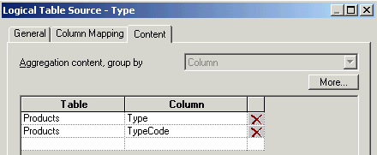
  - Click OK.
- Select File > Check Global Consistency to validate your work.
- Select File > Save to save your work.
- Select File > Exit to close the Administration Tool.
- Return to Services to start services.
  - Start the Siebel Analytics Server.
  - Stop and start the Siebel Analytics Web service.
  - Close Services.
- Start Siebel Answers.
  - Select Start > Programs > Siebel Analytics > Siebel Analytics Web.
  - Enter the following parameters:
User | Administrator
Password | <blank>

  - Click Log In.
  - Click the Answers link.
- Create a request.
  - Select the SupplierSales subject area.
  - Create the following request:
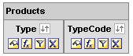
  - Click the Results tab to view the results.
- Examine the query log to determine which table is accessed.
  - Double-click C:\SiebelAnalytics\Log\NQQuery.log.
  - Scroll down and verify that now only the d1_product_type table is accessed in this query.
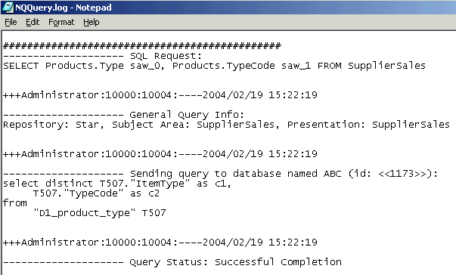
  - Select File > Exit to close the query log.
- Return to Siebel Answers and select File > Close to close the application.
Solutions 5-4 Specifying the Most Economical Source
Answers
2.c. To what physical table and physical column is TypeCode mapped?
TypeCode is mapped to the D1_products physical table and to the TypeCode physical column.
2.d. To what physical table and physical column is Type mapped?
Type is mapped to the D1_product_type physical table and to the ItemType physical column.

